Kahoot instructions
What is Kahoot?
Kahoot is a free game-based learning platform for teathers and classroom
Play, learn, have fun together
How to create a Kahoot
Visit the site https://create.kahoot.it/login and make an account or sigh in with your google account . Click on the New K! button
Choose one of the Quiz, Jungle, Discussion or Survey. In this lesson we will create a Quiz.
Give a title and a description. You can also upload or just drag and drop an image for your Quiz. You can replace all those any time. Choose if you want to do this visible to everyone, the language and Audience (required). You can also add a youtube video as intro video
Then click the button ok,go
Now you are ready to start the quiz. Click on the Add Question and make your first question.
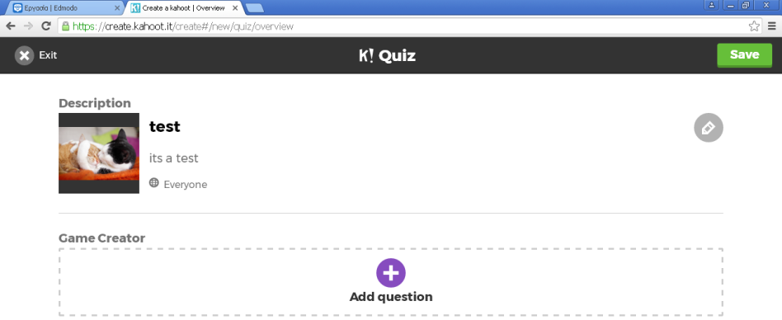
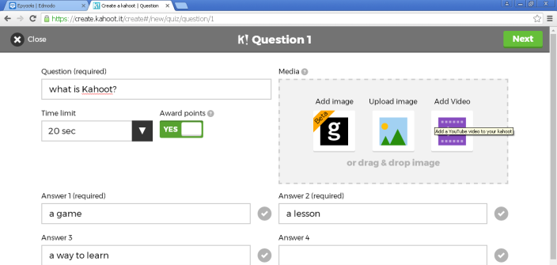
Choose a time limit, a photo or a video for explane something, etc and when you finish click Next.

Don’t forget to choose the correct answer.
When you finish click the save . You will see the url that you must copy and paste to share it. When you click I’m done you will see all your kahoot tests.
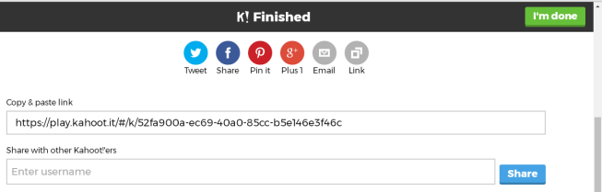
Click on play button and chose the players and you will see the only game pin of your kahoot.

How to play
Visit the url https://kahoot.it Write the Game Pin and click Enter. At next page give a Nick Name and click ok, go

Our teams created 5 Kahoots. You can join on https://kahoot.it/ make an account on the following:
For Migrant 1 https://play.kahoot.it/#/?quizId=29c44513-3b0a-417b-9969-c42fb897e544
For Migrant 2 https://play.kahoot.it/#/?quizId=74ce0a9c-5f4e-4b9b-9d21-63a3ce1c444e
For Migrant 3 https://play.kahoot.it/#/?quizId=505b52f8-8f42-40ca-87c1-6ad4bdc43400
For Migrant 4 https://play.kahoot.it/#/?quizId=cfdbc437-8668-4679-b8f5-1177ecd50a2a and
For Migrant Final https://play.kahoot.it/#/?quizId=18a7924b-28bc-4da5-8580-32883832a631

