Introduction to Edmodo
What is Edmodo?
Edmodo is a free social learning platform for teachers, students and also parents. It offers a safe and easy way for students and teachers to exchange ideas, share content or information and access homework.
Joining Edmodo as a Teacher
Go to https://www.edmodo.com/ If you don’t already have an account, click on “I’m a Teacher”
Enter your details in the spaces provided, then click “Sign Up”. Remember to keep a note of your password.
You will automatically be brought to the “Home” screen. When you initially sign up and log on, this will be empty, but as you join and create groups and join Edmodo communities, this will fill up with updates each day.
Building your Profile
Improve your profile on Edmodo by adding a photo (or avatar) of yourself, connecting with other teachers you know, creating groups that your students join, uploading commonly used files to the library and joining professional learning communities on Edmodo.
Creating a Group
You will set up separate groups for each class you teach. Click the + icon in the “Groups” tab and select “Create” from the menu that appears and name your group.
Select a grade a Subject area, enter the expected group size and then select “Finish”.
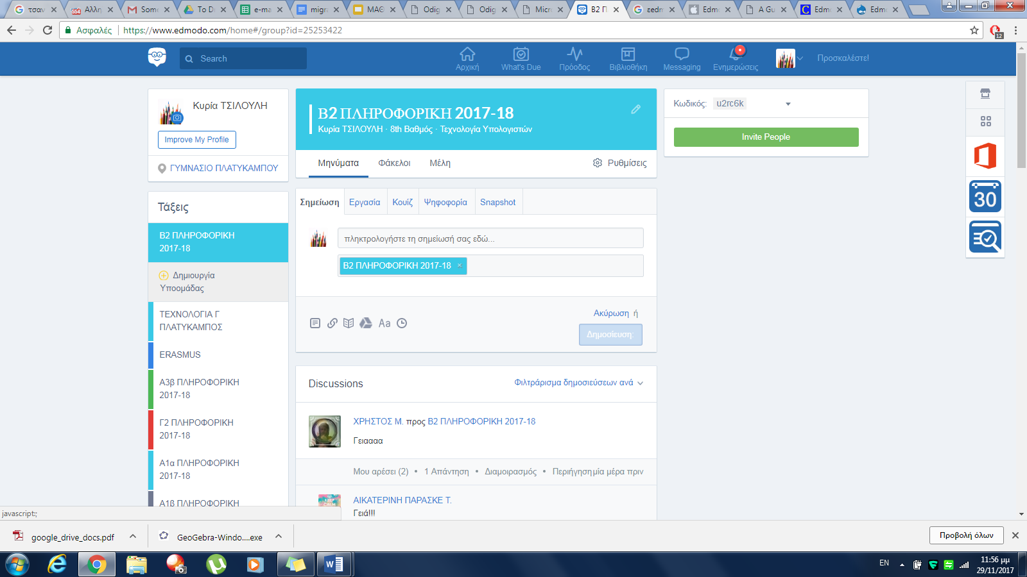
Students will need to have the “Group Code” to join your group. When you have created groups for your classes, you can share the “Group Code” with your students and have them sign up for Edmodo.

Posting on Edmodo
There are a number of options when posting on Edmodo. The first option is to upload a “Note”. This could be a discussion question which students will answer. This is a good way for students to show what they know about a topic. They can search previous posts to revise a topic. Class debates can be started using the “Note” feature. Students can’t privately post to another student, all responses are viewable by everyone who is a member of the group. Files (notes/presentations) and links to websites can be shared with students in a note
An assignment can be given a title and description for students as well as a due date. This is ideal for setting homework. Once an assignment has been created, it can subsequently be re-used with other classes. This is useful if you frequently give similar projects to your first year students
Quizzes/tests can easily be created using the “Quiz” option.
These quizzes/tests are mainly selfcorrecting and allow a time limit and a range of question types, e.g. multiple choice, true/false, matching, fill in the blank and short answer. While “short answer” questions are not self-correcting, the teacher can easily grade these questions quickly and assign a mark for them. Records of student grades can be kept in Edmodo or exported to a spreadsheet
Tracking Student Progress
Student progress can be easily monitored by clicking on the “Progress” icon.
Clicking “Export” will allow you to save this information in an Excel spreadsheet. Click on an individual student to enter their grade, percentages are automatically calculated.
Click on the Badges tab.
Badges can be awarded to students to reward them for work, effort, etc. Edmodo has eight preloaded badges, e.g. good question, hard worker, participant, perfect attendance. Teachers can easily create their own badges to reflect their own student/subject requirements
Creating a Badge
If you would like to create your own individual badges, select “Progress” and click “My Student Badges” from the menu that appears.
Select “Add a new badge!”.
Name the badge you wish to create, give it a brief description and then upload a suitable image. When you have completed this, click “Create Badge”.
Joining as a Student
Students go to https://www.edmodo.com/ and click on “I’m a Student”.
They will need to enter their group join code and their own details in the spaces provided, then click “Sign Up”. Remind them to keep a record of their username and password.

